


SmartRental
Student’s names :-
- Ahmed Maher Abdellatif
- Kirollos Ashraf Gaber
- Mina Samy Sobhy
- Mostafa Safwat Ibrahim
- Yasmeen Mohamed Abdelkhalek Ali

Supervisor :-
- Eng. Osama



Introduction
Finding a suitable house or apartment for rent can be a difficult and time-consuming process. Many people spend hours searching through different websites and social media platforms to find a property that matches their needs and budget. To make this process easier, we developed a web application that allows users to search for and rent houses and apartments through a simple and organized platform.
The website enables users to create an account, log in securely, browse available properties, view detailed information about each property, and choose the most suitable option. The main goal of the project is to provide a convenient and user-friendly solution that simplifies the rental process.
Why We Created This Project
We created this project because finding rental properties is often scattered across multiple platforms, making it difficult for users to compare options and access reliable information. Our objective was to build a centralized system where users can easily find properties, while property owners can present their listings in a professional and organized way.
System Design and Development
The system was developed using modern web technologies. The front-end was built using HTML, CSS, JavaScript, and Bootstrap to create a responsive and user-friendly interface. The back-end was developed using C# and ASP.NET to handle business logic, user authentication, and communication with the database.
During the design phase, we focused on creating a clean interface, simple navigation, and an efficient user experience. We designed the pages to be responsive so that the website can be used on different screen sizes and devices.
Database Design
The database was designed to store and manage all system data efficiently. It contains tables for users, properties, property details, and other related information. Relationships between tables were established to ensure data consistency and integrity.
The database plays a critical role in the system by storing user accounts, login information, property listings, and all data required for the website's functionality.
System Diagrams
Several diagrams were created during the development process to better understand and organize the system structure. These diagrams included:
- Use Case Diagram to identify user interactions with the system.
- Entity Relationship Diagram (ERD) to illustrate database relationships.
- System Flow Diagram to show how information moves through the application.
- Architecture Diagram to demonstrate the interaction between the front-end, back-end, and database.
These diagrams helped us plan the project and maintain a clear development process.
Testing
After development, the system was tested to ensure all features worked correctly. Testing included:
- User Registration and Login.
- Property browsing and searching.
- Database operations.
- Navigation between pages.
- User interface responsiveness.
The results showed that the website performed as expected and provided a smooth user experience.
Challenges and Solutions
Throughout the development process, we faced several challenges. One of the main challenges was connecting the front-end with the back-end and ensuring data was correctly stored and retrieved from the database. This issue was solved by carefully implementing ASP.NET controllers and database queries.
Another challenge was creating a responsive design that worked properly on different devices and screen sizes. We addressed this by using Bootstrap components and testing the website on multiple resolutions.
We also encountered validation and user authentication issues during the login and registration process. These problems were resolved by implementing proper input validation and secure authentication mechanisms.
Conclusion
This project successfully provides a modern web-based solution for renting houses and apartments. By combining a user-friendly interface, a structured database, and reliable back-end functionality, the system offers an efficient platform that simplifies the rental process for users and property owners alike.

A) Project Proposal
Smart_Rental
Student Housing Reservation System
Project Idea
The project is a web application that helps students find and reserve suitable housing easily through an online platform. Students can browse available accommodations, view details, and submit reservation requests without needing to visit multiple places.
Problem Statement
Many students face difficulties when searching for accommodation, especially when moving to a new city or starting their studies. Finding available housing, comparing options, and completing the reservation process can be confusing and time-consuming.
Project Objectives
- Make the housing reservation process easier for students.
- Provide a clear and organized platform for available accommodations.
- Allow students to view housing details before making a reservation.
- Help administrators manage housing information efficiently.
- Reduce the time and effort needed to find suitable accommodation.
Project Scope
The system includes three main users:
Student
- Create an account and log in.
- Browse available housing options.
- View accommodation details.
- Submit housing reservation requests.
Property owner
- Create an account and log in.
- Browse his own listed apartments.
- Add / remove his properties.
- Change property information/status

Admin
- Manage student / owner accounts.
- Maintain the overall system data.
The project focuses on providing an easy and organized housing reservation system through a web application.

B) Project Plan
The project was completed over a period of approximately 3 months. The work was divided into several phases as follows:
Phase | Duration
Requirements Analysis | 2 Weeks
System Design (UI & Database Design) | 2 Weeks
Front-End Development (HTML, CSS, Bootstrap, JavaScript) | 2 Weeks
Back-End Development (C# ASP.NET) | 3 Weeks
Database Development and Integration | 1 Week
Testing and Bug Fixing | 2 Week
Project Timeline
Month 1
- Requirements Analysis
- System Design
- Database Design
Month 2
- Front-End Development
- Creating Website Pages
- User Interface Design
Month 3
- Back-End Development
- Database Integration
- Testing and Bug Fixing
- Final Project Deployment
The project was developed step by step, starting with analysis and design, followed by implementation of the front-end and back-end components, database integration, and finally testing to ensure that all features worked correctly.

C) Task Assignment & Roles
The project was developed as a team effort, and all team members contributed to different parts of the system. We worked together throughout the project and supported each other whenever challenges or issues appeared.
Although each member had specific responsibilities, we regularly shared ideas, reviewed each other's work, and collaborated to ensure the project was completed successfully.
The team participated in:
- Requirements analysis and project planning.
- Designing the user interface and system structure.
- Front-end development using HTML, CSS, Bootstrap, and JavaScript.
- Back-end development using C# and ASP.NET.
- Database design and implementation.
- Testing the system and fixing errors.
- Preparing the project documentation and presentation.
Working as a team helped us complete the project more efficiently and allowed us to learn from each other's experience. Everyone contributed to the project and supported the team whenever needed.

D) Risk Assessment
During the development of the project, we faced some challenges that could have affected our progress.
One of the main risks was technical issues, such as coding errors, database connection problems, and bugs that appeared during development. We solved these issues through testing, debugging, and teamwork until the system worked correctly.
Another challenge was time management. Sometimes, some team members were unable to complete their tasks on time because of academic commitments, exams, or personal circumstances. These delays were not intentional and were beyond their control. To overcome this issue, other team members provided support and helped complete urgent tasks to keep the project on schedule.
We also faced difficulties in integrating the front-end, back-end, and database components. Through regular communication and collaboration, we were able to solve these problems and ensure that all parts of the system worked together successfully.
Overall, teamwork, communication, and continuous testing helped us reduce risks and complete the project successfully.
E) KPIs (Key Performance Indicators)
To measure the success of the project, we used several performance indicators:
1. System Performance
The website should load pages quickly and respond smoothly to user requests without significant delays.
2. User Satisfaction
Users should be able to navigate the website easily, find suitable housing, and complete the reservation process without difficulties.
3. Number of Users
The system should be able to support multiple users and handle their activities efficiently.
4. Error Rate
The number of system errors and bugs should be kept as low as possible through continuous testing and maintenance.
5. Database Accuracy
User information, housing details, and reservation data should be stored and retrieved correctly without data loss.
6. Successful Reservation Requests
The system should allow students to submit and manage reservation requests successfully and without technical issues.
7. System Availability
The website should remain available and accessible to users whenever needed.
These indicators help evaluate the quality, reliability, and overall success of the project.

2) Literature Review
Before starting the project, we reviewed several housing and accommodation booking websites to understand their features and identify areas for improvement. We studied how these systems allow users to search for housing, view property details, and make reservations online.
Some existing systems provide many features, but they can sometimes be difficult to use, contain unnecessary information, or have a complicated booking process. We used these observations to help us design a simpler and more user-friendly solution.

Comparison with Existing Systems

Feature | Existing Systems | Our System
Housing Search | Available | Available
View Housing Details | Available | Available
User-Friendly Interface | Varies | Simple and Easy to Use
Student-Focused Design | Not Always | Yes
Easy Reservation Process | Sometimes Complex | Simple and Direct
Why Our Project is Better
Our project focuses on simplicity and ease of use. Instead of providing too many complex features, we designed a system that helps students find and reserve housing quickly and efficiently.
The main advantages of our system are:
- Simple and clean user interface.
- Easy navigation between pages.
- Fast access to housing information.
- Organized reservation process.
- Designed specifically for students and their needs.
Source of Ideas
The ideas for this project came from observing the difficulties students face when searching for accommodation. We also gained inspiration from existing housing and booking websites, then selected the most useful features and adapted them to create a system that is easier to use and more suitable for students.
By combining these ideas with our own improvements, we developed a web application that provides a better and more organized housing reservation experience.

3) Requirements Gathering
A) Stakeholder Analysis
The system has different types of users (stakeholders) who will interact with the application. Each user has different roles and permissions depending on their needs.
1. Admin
The admin is responsible for managing the whole system.
The admin can:
- Manage user accounts.
- Maintain and control the system data.
2. User (Student)
The student is the main user of the system.
The student can:
- Create an account and log in.
- Browse available houses and apartments.
- View details of each property.
- Send reservation requests.
3. Property Owner
The property owner manages his apartment listing by:
- Review listings and reservations.
- Add/Remove properties.
- Edit apartment information and availability.

B) User Stories
In this project, we described the system from the user’s point of view to understand their real needs and problems.

User Story 1: Student Searching for Housing
As a student who is new to a city, I want to find a suitable place to live easily so that I do not waste time searching in many different places.
Many students face difficulties when they move to a new city for studying. They often do not know where to start or who to trust when looking for accommodation.

User Story 2: Difficulty in Finding Safe Housing
As a student, I want a trusted platform to view real housing options so that I can avoid unsafe or unreliable offers.
Without a proper system, students may depend on random sources or unknown people, which increases the risk of scams or losing money.

User Story 3: Easy Reservation Process
As a student, I want to be able to reserve housing online in a simple way so that I can complete the process without stress or confusion.
Many students struggle with complicated booking methods or unclear communication with property owners.

C) Use Cases
This section explains the main operations that users can perform in the system. These use cases describe how both students and admin interact with the website.
1. Register
New users (students) can create a new account by entering their personal information such as name, email, and password.
2. Login
Registered users can log in to the system using their email and password to access their account.
3. Search Housing
Students can search for available houses or apartments based on their needs, such as location, price, or type of housing.
4. View Housing Details
Users can open any property to see full details such as description, price, location, and available features.
5. Make Reservation
Students can send a request to reserve a selected house or apartment through the system.
6. Add Comment (Optional Feature)
Users may add comments or feedback about housing options to help other students.
7. Admin Management
The admin can:
- Add new housing listings.
- Edit or update existing properties.
- Delete unavailable listings.
- Manage users and reservations.
D) Functional Requirements
This section describes the main functions that the system must provide in order to work properly and meet user needs.
1. User Registration
The system must allow new users (students) to create an account by entering their personal information.
2. User Login
The system must allow registered users to log in securely using their email and password.
3. Manage Users
The system must allow the admin to:
- Add new users.
- Edit user information.
- Delete users when needed.
4. Manage Housing Listings
The system must allow the admin to:
- Add new housing (houses or apartments).
- Update housing details such as price, location, and description.
- Delete unavailable housing.
5. Search Housing
The system must allow users to search for available housing easily based on different filters.
6. View Housing Details
The system must show full details of each property, including description, images, and price.
7. Reservation System
The system must allow students to send reservation requests for selected housing.

8. Comment / Feedback (Optional)
The system may allow users to add comments or feedback about housing options.
E) Non-Functional Requirements
This section describes the quality and characteristics of the system rather than specific functions. These requirements ensure that the system works in a good and reliable way.
1. Security
The system must protect user data such as login information and personal details. Only registered users should be able to access their accounts.
2. Performance
The system should respond quickly when users search, open pages, or send reservation requests, without noticeable delay.
3. Usability
The website should be simple and easy to use so that any student can navigate it without technical experience.
4. Reliability
The system should work correctly most of the time without crashing or losing data, and it should provide stable performance.
5. Availability
The system should be available for users at any time so they can access housing information whenever they need it.
6. Maintainability
The system should be easy to update and fix in case of errors or future improvements.
4) System Analysis & Design
This section explains how the system was designed and implemented, including the structure of the website, the main components of the code, and the overall design choices.
System Overview
The system is a web-based housing reservation platform that allows students to search for and book available accommodations. It is built using HTML, CSS, JavaScript, Bootstrap for the front-end, and C# with ASP.NET for the back-end.
Front-End Design
The front-end was designed to be simple, clean, and easy to use. We used Bootstrap to make the website responsive so it works on different screen sizes like mobile, tablet, and desktop.
We focused on:
- Simple navigation between pages.
- Clear layout for housing listings.
- Attractive but minimal design to avoid confusion.
- Easy access to important features like search and login.
The design was chosen to make the user experience smooth and fast, especially for students who need quick access to housing information.
Back-End Structure
The back-end was developed using C# and ASP.NET. It handles:
- User authentication (Login & Register).
- Managing housing data.
- Processing reservation requests.
- Connecting the system with the database.
The back-end ensures that all user actions are processed correctly and securely.
Database Integration
The system is connected to a database that stores:
- User information.
- Housing listings.
- Reservation data.
The database ensures that all data is saved and retrieved efficiently when needed.
Code Explanation
- HTML was used to create the structure of the web pages.
- CSS was used to style the website and make it visually attractive.
- JavaScript was used to add interactivity such as form validation and dynamic actions.
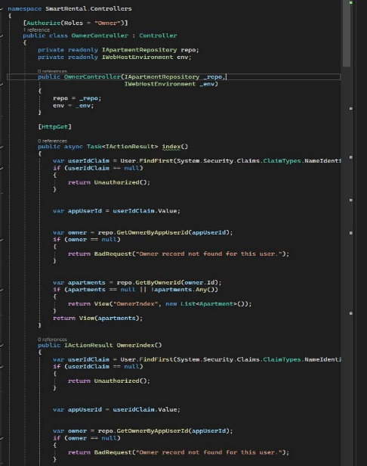
- Bootstrap was used to make the design responsive and modern.
- C# ASP.NET was used to handle server-side logic and connect the website with the database.
System Screenshots
Here you can add screenshots of your project such as:
- Home Page
- Login Page
- Register Page
- Housing Listings Page
- Reservation Page
- Admin Dashboard
These screenshots help explain how the system looks and how it works in real life.
Design Rationale (Why We Chose This Design)
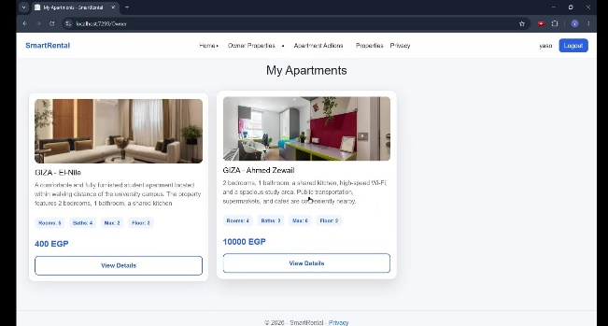
We chose this design because it is:
- Simple and easy to understand for students.
- Fast and responsive on all devices.
- Organized to avoid confusion.
- Focused on user experience and clarity.

5) Problem Statement & Objectives
Problem Statement
Finding suitable housing is a common problem for many students, especially those who move to a new city for study. The process of searching for accommodation is often difficult, unorganized, and time-consuming.
Students usually depend on different sources such as social media, personal contacts, or random advertisements. This can lead to several problems, such as:
- Lack of reliable and verified housing information.
- Difficulty in comparing different housing options.
- Time wasted in searching through many different places.
- Risk of dealing with unreliable or fake offers.
- Confusion in communication between students and property owners.
On the other hand, property owners may also face difficulties in reaching the right students and managing reservations in an organized way.
Objectives
The main objective of this project is to develop a simple and organized web-based system that helps solve these problems.
The specific objectives are:
- To make the process of finding housing easier for students.
- To provide a single platform that contains all available housing options.
- To allow users to view detailed and accurate information about properties.
- To reduce the time and effort needed to search for accommodation.
- To improve communication between students and property owners.
- To provide a secure and reliable reservation system.

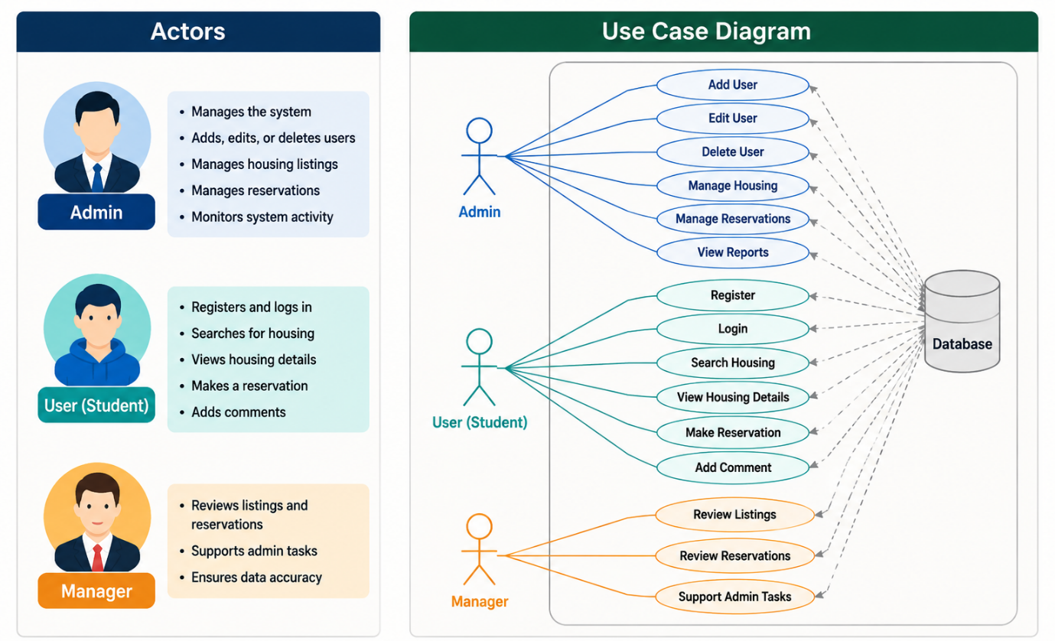
B) Use Case Diagram

D) Database Design & Data Modelling

ER Diagram
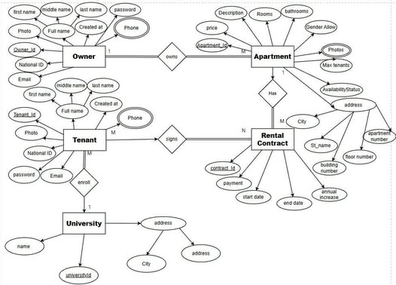

Logical & Physical Schema
1. Owner (Landlord)
Logical Schema
The Owner entity represents the person who owns one or more apartments in the system.
Each owner has personal and contact information, and may have multiple phone numbers.
Attributes:
- Owner_Id (Primary Key): Unique identifier for the owner.
- first_name: First name of the owner.
- middle_name: Middle name of the owner.
- last_name: Last name of the owner.
- email: Email address of the owner.
- password: Account password.
- National_ID: National identification number.
- Photo: Profile image.
- Created_at: Account creation timestamp.
Multi-valued Attribute:
- Phone: An owner can have more than one phone number, so it is stored in a separate table.

2. Apartment
Logical Schema
The Apartment entity represents the property available for rent.
Each apartment contains detailed information about its specifications, location, and availability.
Attributes:
- Apartment_Id (Primary Key): Unique identifier for each apartment.
- price: Monthly rent price.
- Description: Description of the apartment.
- Rooms: Number of rooms.
- bathrooms: Number of bathrooms.
- Gender_Allow: Allowed tenant type (e.g., male, female, families).
- Max_tenants: Maximum number of tenants allowed.
- AvailabilityStatus: Current availability status.
- City: City name.
- St_name: Street name.
- building_number: Building number.
- floor_number: Floor number.
- apartment_number: Apartment number.
- Owner_Id (Foreign Key): References the owner of the apartment.
Multi-valued Attribute:
- Photos: Each apartment can have multiple images stored separately.
Relationships:
- One Owner can own many Apartments (1:M).
- Each Apartment must belong to exactly one Owner (total participation).

3. Tenant (Renter / Student)
Logical Schema
The Tenant entity represents the person who rents an apartment.
The tenant data structure is similar to the owner.
Attributes:
- Tenant_Id (Primary Key): Unique identifier for each tenant.
- first_name: First name.
- middle_name: Middle name.
- last_name: Last name.
- email: Email address.
- password: Account password.
- National_ID: National identification number.
- Photo: Profile image.
- Created_at: Account creation timestamp.
- universityId (Foreign Key): Links tenant to a university.
Multi-valued Attribute:
- Phone: Each tenant can have multiple phone numbers.

4. University
Logical Schema
The University entity represents the educational institution where tenants study.
Attributes:
- universityId (Primary Key): Unique identifier for the university.
- name: University name.
- City: City where the university is located.
- address_detail: Detailed address.
Relationships:
- One University can have many Tenants (1:M).
- Each Tenant belongs to one University.

5. Rental Contract
Logical Schema
The Rental Contract entity represents the agreement between a tenant and an apartment.
It is used to track rental details and duration.
Attributes:
- contract_Id (Primary Key): Unique contract identifier.
- payment: Rental payment amount.
- start_date: Contract start date.
- end_date: Contract end date.
- annual_increase: Annual rent increase percentage.
- Apartment_Id (Foreign Key): References the rented apartment.
- Tenant_Id (Foreign Key): References the tenant.
Relationships:
- A Tenant can have multiple rental contracts over time.
- An Apartment can be rented multiple times over time.
- The Rental Contract acts as a bridge between Tenant and Apartment (M:N relationship resolved into a separate entity).
System Deployment & Integration
Technology Stack
The system is developed using a full-stack web development approach. The selected technologies were chosen to ensure scalability, maintainability, and strong integration between frontend, backend, and database layers.
1. Frontend
The frontend layer is responsible for the presentation and user interaction of the system.
Technologies Used:
- HTML
- CSS
- JavaScript
- ASP.NET MVC Views (Razor)

Purpose:
- HTML is used to structure web pages.
- CSS is used for styling and layout.
- JavaScript is used for basic client-side interactions and form validation.

2. Backend
The backend layer handles the core logic of the system.
Technologies Used:
- C#
- ASP.NET Core / ASP.NET MVC (.NET Framework or .NET Core)
Purpose:
- C# is the main programming language used to implement business logic.
- ASP.NET MVC is used to build the web application using the Model–View–Controller pattern.
- Controllers handle requests, process data, and communicate with the database.
- Entity Framework is used for database operations and ORM mapping.

3. Database
The database layer is responsible for storing and managing all system data.
Technologies Used:
- Microsoft SQL Server
Purpose:
- SQL Server is used as a relational database management system (RDBMS).
- It stores all system data such as users, apartments, tenants, contracts, and related entities.
- It ensures data integrity through primary keys, foreign keys, and relationships.

Why These Technologies Were Chosen
The selected technologies were chosen based on reliability, performance, and industry usage:
- HTML, CSS, JavaScript: Standard technologies for building web interfaces and supported by all browsers.
- C# and ASP.NET MVC: A powerful backend framework developed by Microsoft in 2002, widely used for enterprise-level web applications due to its security, scalability, and integration with the .NET ecosystem.
- SQL Server: A robust relational database system developed by Microsoft, used for handling structured data with high performance and strong security features.

System Integration
The system follows a layered architecture where all components are integrated as follows:
- The frontend sends requests to the backend through HTTP.
- The backend processes the request using Controllers and business logic.
- The backend communicates with the SQL Server database to retrieve or store data.
- The response is returned back to the frontend and displayed to the use
Component Diagram
Overview
The Component Diagram represents the high-level structure of the system and shows how different components interact with each other in the ASP.NET MVC architecture.
The_system_is_divided_into_three,main_components:
Frontend (Views), Backend (Controllers + Business Logic), and Database.

System Components
1. Frontend (Views)
The frontend is implemented using ASP.NET MVC Views (Razor Pages).
Responsibilities:
- Display data to the user
- Send user requests to the backend
- Receive and render responses from the server
The frontend does not contain business logic; it only handles presentation.

2. Backend (Controllers + Business Logic)
The backend is implemented using ASP.NET MVC Controllers written in C#.
Responsibilities:
- Handle HTTP requests from the frontend
- Execute business logic
- Validate and process data
- Communicate with the database using Entity Framework
Each entity in the system (Owner, Tenant, Apartment, Contract) has its own controller.

3. Database (SQL Server)
The database component is responsible for storing all system data.
Responsibilities:
- Store persistent data (Users, Apartments, Contracts, etc.)
- Maintain relationships between tables
- Ensure data integrity using primary and foreign keys

Component Interaction Flow
The system components interact as follows:
Frontend (Views)
↓
Controllers (ASP.NET MVC Backend)
↓
Business Logic Layer (C# Services / EF Core)
↓
Database (SQL Server)

How Components Are Connected
- The Views send requests to Controllers using HTTP requests.
- Controllers process the request and call the business logic layer.
- Business logic communicates with the database using Entity Framework.
- Data is returned back to the Controller.
- Controller sends the final result to the View.

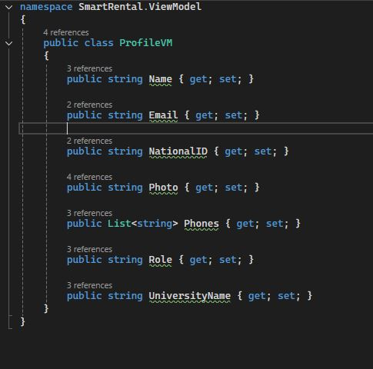
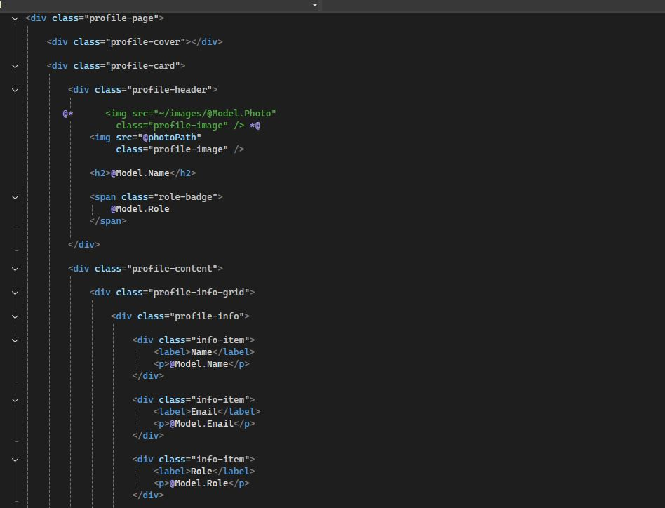
These are screenshots of the project source code implementation
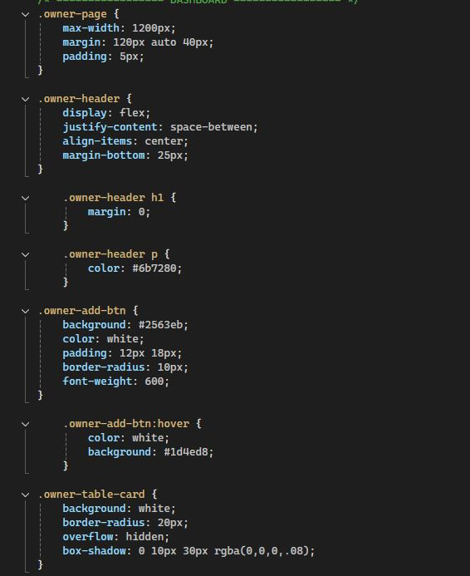
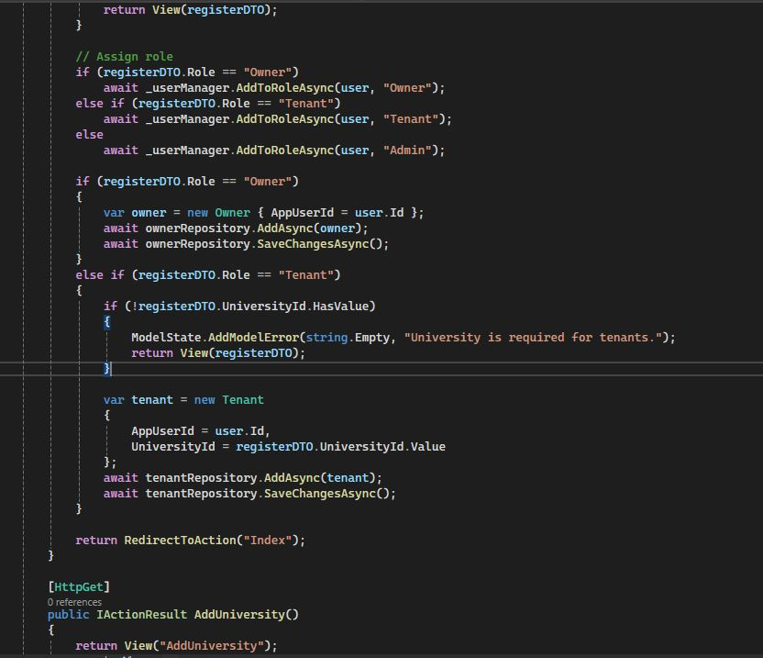



Thank you

